1. Let’s talk about Mongodb Structure.
2. There is database.
3. Database consists of collections.
4. Each collection contains documents.
5. Documents are grouped into a collection by common characteristics.
6. 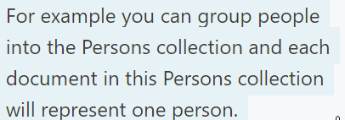
7. All documents in one collection need not to have some set of fields.
8. Each document in mongoDB is stored in BSON format.
9. MongoDB 🡺 Databases 🡺 Collections 🡺 Documents 🡺 BSON formats.
10. 